Firewall Detection & IDS Evasion:
DEMO:
Detect the presence of Firewall:
Nmap -h
ACK scan : sA
# packet with ACK flag set, tell us the open port are filtered (stateful firewall) or unfiltered/open.

Nmap -sn target_ip
# ping to discover host

Nmap -Pn -sS -F target_ip
# F: 100 common port
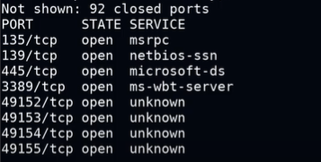
It there is a firewall the 92 closed port will be 92 filtered ports, viceversa.

Nmap -Pn -sA -p445,3389 target_ip
#it tell us about the firewall
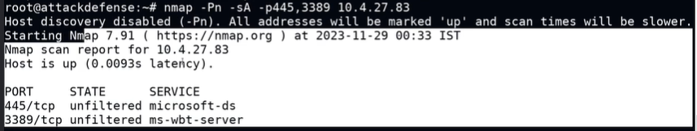
If there is a firewall it shows the filtered.

Firewall ,IDS Evasion:
Nmap -h
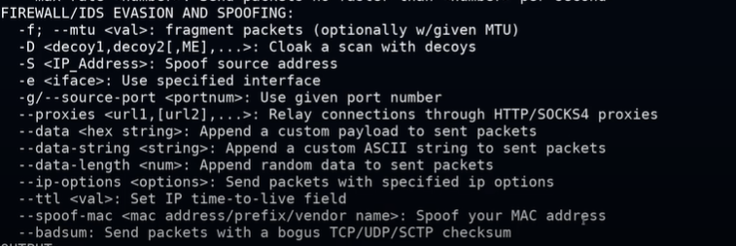

Fragment helps to bypass the IDS.
Fragment the packet into small.

Nmap -Pn -sS -sV -F target_ip
# to see the change open the wireshark
# it does the simple scan no fragmentation.

Nmap -Pn -sS -sV -p80,445,3389 -f target_ip
# now the packets become fragmented.
# seen in the wireshark
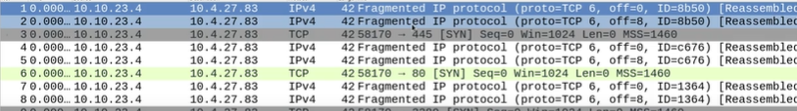
# default fragmented in 2 packets.

Nmap -Pn -sS -sV -p80,445,3389 -f - -mtu 32 target_ip
# Nmap will send fragmented TCP SYN packets in chunks of 32 bytes.

Nmap -Pn -sS -sV -p80,445,3389 -f - -mtu 8 target_ip
# Nmap will send fragmented TCP SYN packets in chunks of 8 bytes.

Spoofing / Decoy ip:
# make it for the gateway so that what packets are send are like to be come from the gateway the only requirement for this is to be a part of network.

Instructors use to evade are: (important)
Set the ttl value for the packet, it is also very useful.
--data-length --- append random data to send packets.
Disable DNS resolution. -n

Nmap -Pn -sS -sV -p 445,3389 -f -- data-length 200 -D gateway_ip ,other ip’s target_ip
# evade detection and attribution,

Change the source port(attacker):
Nmap -Pn -sS -sV -p 445,3389 -f -- data-length 200 -g 53 -D gateway_ip ,other ip’s target_ip
# g 53 : it comes form the port 53.

NOTE:
Fragment breaking them down into small packets.
MTU stands for maximum transmitted unit.
The number you give must be a multiple of 8 (so 8, 16, 24, 32, etc.) in MTU.
In every network the first ip is reserved for the gateway.

Fragment Offset.
- When a big IP packet is broken into smaller pieces (fragments), each piece needs a "tag" so the receiver knows where to put it back.
- That "tag" is the Fragment Offset.
- It says: “This fragment starts at byte number X of the original packet.”
- The number is stored in 8-byte chunks (so Offset = 1 means start at byte 8, Offset = 2 means start at byte 16, etc.).

--data-length <n> tells Nmap to append n bytes of random payload to each probe packet (changing packet size).

IP spoofing: forging the source IP address in packets to hide the sender or impersonate another host.
Decoy IP: sending additional fake-source probes or traffic (decoys) to confuse defenders and mask the real scanner’s origin.

• Important: many decoys are just forged source addresses. If the target responds, replies go to the forged addresses — you may not receive responses from some spoofed probes, so Nmap correlates replies it does receive to determine the real result.
• If you include a gateway or another real host as a decoy you can cause confusing/false alerts on that host or get that host blamed — don’t do this on networks you don’t own.

TTL is decremented by 1 at each router hop — when it hits 0 the packet is dropped and an ICMP “Time Exceeded” is sent back —
so --ttl controls how many hops your probe can travel.

